ASSIGNMENT-2

Name: R. Uday kumar reddy Regd.no:192424190
Course code & Name: DSA0216 & Computer Vision with OpenCV for Modern AI

For Edge Detection Compute the following
1.Given a 3×3 image matrix and Sobel X kernel, compute the gradient manually.
Manual Computation of Gradient using Sobel X
Given:
3×3 Image Matrix (I):
$$I=\left[\begin{matrix}10 & 20 & 30 \\ 40 & 50 & 60 \\ 70 & 80 & 90\end{matrix}\right]$$
Sobel X Kernel (Gx):
$$G_{x}=\left[\begin{matrix}-1 & 0 & 1 \\ -2 & 0 & 2 \\ -1 & 0 & 1\end{matrix}\right]$$
Step 1: Convolution Process
Convolution involves:
- Multiplying each corresponding element
- Adding all the products
$$G_{x}=∑(I(i,j)×G_{x}(i,j)) \\ =(-1×10)+(0×20)+(1×30) \\ +(-2×40)+(0×50)+(2×60) \\ +(-1×70)+(0×80)+(1×90)$$
Step 2: Calculate
$$=(-10+0+30) \\ +(-80+0+120) \\ +(-70+0+90) \\ =20+40+20 \\ =80$$
Interpretation
- Positive value → Edge intensity increasing left to right
- Large magnitude → Strong edge
- If negative → Edge intensity decreasing
$$\boxed{G_{x}=80}$$
2. For an image of size 7×7 and a 3×3 kernel with stride 1 and no padding, calculate output size.
Output Size Calculation (7×7 Image, 3×3 Kernel, Stride 1, No Padding)
Formula:
$$\text{Output Size}=\frac{\left(N-F+2P\right)}{S}+1$$
Where:
- N = Input size = 7
- F = Filter size = 3
- P = Padding = 0
- S = Stride = 1

Substituting:
$$=\frac{\left(7-3+0\right)}{1}+1 \\ =\frac{4}{1}+1 \\ =4+1 \\ =5$$

Final Output Size:
$$\boxed{5×5}$$

3. Write a Python program to apply Sobel edge detection on a grayscale image.
Python Program – Sobel Edge Detection
Sobel operator:
- Computes first-order derivative
- Detects horizontal and vertical edges
- Combines gradients using magnitude formula:
$$G=\sqrt{G_{x}^{2}+G_{y}^{2}}$$
Input code:
import cv2
import numpy as np
import matplotlib.pyplot as plt
from google.colab import files
uploaded = files.upload()
image_path = list(uploaded.keys())[0]
img = cv2.imread(image_path, cv2.IMREAD_GRAYSCALE)
sobel_x = cv2.Sobel(img, cv2.CV_64F, 1, 0, ksize=3)
sobel_y = cv2.Sobel(img, cv2.CV_64F, 0, 1, ksize=3)
sobel_magnitude = np.sqrt(sobel_x**2 + sobel_y**2)
sobel_magnitude = np.uint8(np.absolute(sobel_magnitude))
plt.figure(figsize=(12,5))
plt.subplot(1,4,1)
plt.title("Original")
plt.imshow(img, cmap='gray')
plt.axis("off")
plt.subplot(1,4,2)
plt.title("Sobel X")
plt.imshow(sobel_x, cmap='gray')
plt.axis("off")
plt.subplot(1,4,3)
plt.title("Sobel Y")
plt.imshow(sobel_y, cmap='gray')
plt.axis("off")
plt.subplot(1,4,4)
plt.title("Sobel Magnitude")
plt.imshow(sobel_magnitude, cmap='gray')
plt.axis("off")
plt.show()
output:
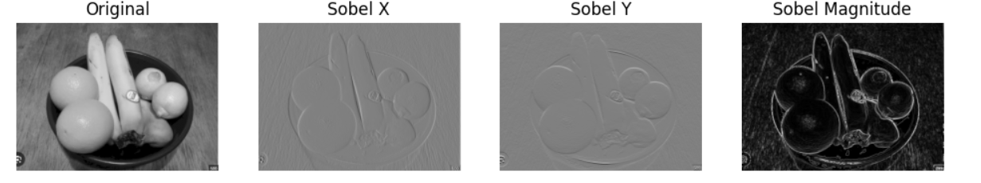
4. Which method is more sensitive to noise? Explain
First-Order Derivative Methods
- Sobel
- Prewitt
- Roberts
These compute gradient (first derivative).
They are sensitive to noise but less than second-order methods.
Sobel is slightly better than Prewitt because:
- It includes smoothing effect (central coefficient = 2).
- Reduces noise impact slightly.

Second-Order Derivative Method
- Laplacian Operator
Formula:
$$∇^{2}f=\frac{∂^{2}f}{∂x^{2}}+\frac{∂^{2}f}{∂y^{2}}$$
Characteristics:
- Detects zero-crossings
- Very sensitive to noise
- Amplifies high-frequency components
Since noise contains high-frequency variations, second derivatives amplify noise significantly.
- Canny Edge Detector
Steps:
- Gaussian smoothing
- Gradient computation
- Non-maximum suppression
- Double threshold
- Edge tracking
Because of Gaussian filtering step:
- Canny is least sensitive to noise
- Produces thin and accurate edges

Conclusion
Method | Noise Sensitivity
Roberts | High
Prewitt | Moderate
Sobel | Moderate (less than Prewitt)
Laplacian | Very High
Canny | Low
✔ Most Sensitive to Noise:
$$\boxed{\text{Laplacian Operator}}$$
- Because second-order derivatives amplify noise strongly.

